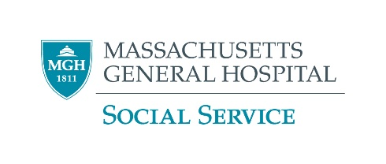

**Donating a Body or Skeletal Remains**

**to Medical Science**

**Whole Body Anatomical Gifts Programs**

* Any adult (18 or over) who has not been declared incompetent may bequeath their body to a medical school.
* Registering as an organ donor through your driver’s license does not give permission to donate your body. Arrange to donate your body using the “Instrument of Anatomical Gift” form available from one of the following institutions. Families/next of kin cannot donate a body after death (but they may be able to donate skeletal remains- see next program below).
* There are some circumstances that may render the body inappropriate for teaching purposes, including communicable diseases or if the body was badly disfigured, if an autopsy has been performed, or if organs (other than corneas) have been donated. There are also other situations in which the school may not be able to use a body, so it is wise to have a back-up plan.
* The medical school must be informed within 24 hours of the death as the body must be quickly transported and refrigerated. This tight time-line means that families are rarely able to have a funeral service with the body present.
* It may take 1 to 2 years for the medical school to use the body for teaching purposes.
* In Massachusetts, unless the family requests the remains, after the body has fulfilled its educational purposes, the medical schools transport cremated remains to a vault in Pine Hill Cemetery in Tewksbury.
* One may arrange for the donation of his or her body after death by executing the “Instrument of Anatomical Gift” form available from one of the following institutions. It is not sufficient to indicate intent on a donor card or driver’s license. Families/next of kin cannot donate a body after death. But see next program for donation of Skeletal Remains.

|  |  |
| --- | --- |
| **Boston University** (617) 358-2105 (617) 638-4144* | **Tufts University** (617) 636-0837  (617) 636-6610* |
| **Harvard University** (617) 432-1735 (617) 432-1379* | **UMass Medical School** (508) 856-2460 (508) 856-2460* Left VM (4/21) |

**For information and resources about a former **Harvard** Medical School employee’s unlawful interstate transport of stolen human remains prior to August 2022 please see [hms.harvard.edu/news-events/anatomical-gift-program-resources](https://hms.harvard.edu/news-events/anatomical-gift-program-resources)

*Phone number to be used nights, weekends, and holidays.

**Boston University Donated Osteological Collection – Skeletal Remains**

Boston University Medical school is creating a collection of skeletons for use in the Forensic Anthropology Master’s Degree program as well as by medical/dental classes and by the State Police. The program can accept an after-death donation made by the deceased’s legal next of kin. Unlike whole body donation programs, this program can also accept donations that have been autopsied, have had extensive surgery or have donated organs for transplant. For more information or to donate, please contact:

Lee A. Faris, Forensic Anthropology Gift Administrator  
[leeanne@bu.edu](mailto:leeanne@bu.edu)  
617-358-2105